Cross-quantilogram: GBPUSD and EURGBP
Method 20 / daily log returns / expanding quantiles / Alpari D1 full available history

Study setup
Logical pair: GBPUSD , EURGBP
Broker symbols: GBPUSD_i , EURGBP_i
Snapshot: 2026-11-03_majors_alpari_D1
Timeframe: D1
Matched return window: 1999-01-06 to 2026-11-02 (UTC bar dates)
Matched return count n: 7199
Dropped unfinished last bar dated 2026-11-03 UTC after a tick-volume check against the prior complete day.
Quantiles: expanding window, min history 252 days
tau in [0.05, 0.2]; k=0..10; headline tau=0.05, k=1
Complete matched rows (Excel): GBPUSD-EURGBP_CQ_D1.xlsx
Complete matched rows (HTML table): GBPUSD-EURGBP_CQ_D1_data.html

Method carried forward
The cross-quantilogram rho_tau(k) measures linkage among centered quantile-hit indicators of matched daily log returns of close, ln(close_t / close_t-1). Quotes are not inverted. At each date t, the tau-quantile uses only returns through t (expanding window) after a minimum history of 252 days. Hits are h_t = 1(r_t < q_t) - tau. rho_tau(k) is the normalized cross-product of h_x,t with h_y,t+k. Levels tau in {0.05, 0.20} and lags k=0..10 are pre-specified; headline is tau=0.05, k=1 both directions. Same-sample Pearson r is a side check. This is not causation and not a trading signal.

Results (headline)
rho_GBPUSD->EURGBP(tau=0.05,k=1): 0.034405
rho_EURGBP->GBPUSD(tau=0.05,k=1): 0.031021
rho_GBPUSD->EURGBP(tau=0.20,k=1): 0.015345
rho_EURGBP->GBPUSD(tau=0.20,k=1): 0.021070
Pearson r: -0.397845

CQ table (tau=0.05)
k | rho_GBPUSD_to_EURGBP | n_GBPUSD_to_EURGBP | rho_EURGBP_to_GBPUSD | n_EURGBP_to_GBPUSD
0 | -0.01972736 | 6948 | -0.01972736 | 6948
1 | 0.03440474 | 6947 | 0.03102094 | 6947
2 | 0.03101275 | 6946 | 0.04793187 | 6946
3 | 0.05469153 | 6945 | 0.03777226 | 6945
4 | 0.04114801 | 6944 | 0.0242286 | 6944
5 | 0.08513074 | 6943 | 0.03775599 | 6943
6 | 0.07158725 | 6942 | 0.02759603 | 6942
7 | 0.03097177 | 6941 | 0.04450765 | 6941
8 | 0.03096358 | 6940 | 0.02081159 | 6940
9 | 0.01741928 | 6939 | 0.04110746 | 6939
10 | 0.02417908 | 6938 | 0.04109935 | 6938

Conclusion
Headline tau=0.05, k=1 for GBPUSD and EURGBP: rho_GBPUSD->EURGBP = 0.0344; rho_EURGBP->GBPUSD = 0.0310. At tau=0.20, k=1: 0.0153 and 0.0211. Same-day tau=0.05 rho(k=0) = -0.0197. Pearson r = -0.3978. This is quantile-hit linkage, not a trading signal.

Charts
Daily closes

Daily log returns

Cross-quantilogram tau=0.05
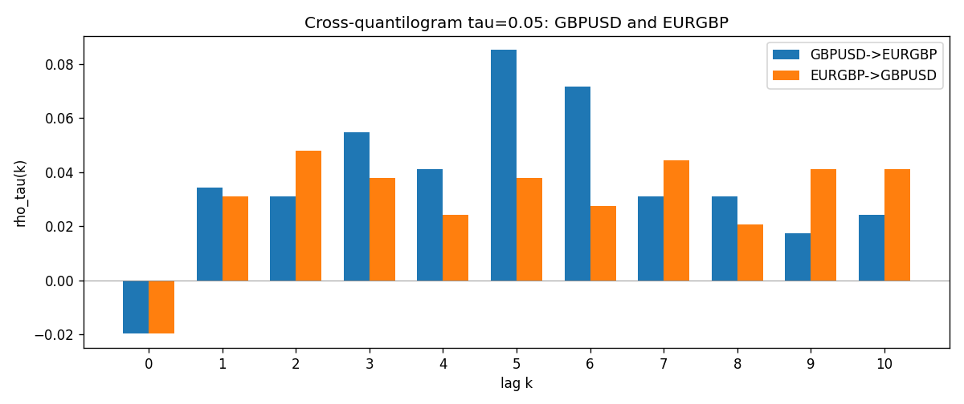

Data report
Matched rows and the CQ sheet are in the sibling Excel workbook named GBPUSD-EURGBP_CQ_D1.xlsx. Embedding all rows as a Word table is impractical; this file holds column summaries and the first and last 15 matched rows.
Columns: time, GBPUSD_open, EURGBP_open, GBPUSD_high, EURGBP_high, GBPUSD_low, EURGBP_low, GBPUSD_close, EURGBP_close, GBPUSD_tick_volume, EURGBP_tick_volume, GBPUSD_spread, EURGBP_spread, GBPUSD_real_volume, EURGBP_real_volume, GBPUSD_log_return, EURGBP_log_return, GBPUSD_h_t005, EURGBP_h_t005
Column summaries (matched calculation rows)
column | count | mean | std | min | 25% | 50% | 75% | max
GBPUSD_open | 7199 | 1.5160931 | 0.21831499 | 1.06854 | 1.324955 | 1.5114 | 1.63186 | 2.1066
EURGBP_open | 7199 | 0.78665041 | 0.09676322 | 0.5734 | 0.6873 | 0.83367 | 0.865175 | 0.9769
GBPUSD_high | 7199 | 1.5223838 | 0.21887686 | 1.08366 | 1.32978 | 1.5181 | 1.6384 | 2.1161
EURGBP_high | 7199 | 0.78972718 | 0.09713886 | 0.5789 | 0.68935 | 0.83657 | 0.86804 | 0.9799
GBPUSD_low | 7199 | 1.5097628 | 0.21753729 | 1.03518 | 1.3194 | 1.50323 | 1.62442 | 2.0983
EURGBP_low | 7199 | 0.78395066 | 0.09658082 | 0.5682 | 0.6853 | 0.83147 | 0.862765 | 0.9661
GBPUSD_close | 7199 | 1.5161471 | 0.21826306 | 1.06879 | 1.325055 | 1.51122 | 1.63216 | 2.1065
EURGBP_close | 7199 | 0.78669405 | 0.09676312 | 0.5735 | 0.6875 | 0.8337 | 0.86528 | 0.977
GBPUSD_tick_volume | 7199 | 94850.986 | 153561.38 | 62 | 9998.5 | 52911 | 91818.5 | 1273370
EURGBP_tick_volume | 7199 | 86949.029 | 145390.09 | 154 | 6517.5 | 44265 | 81326 | 1424684
GBPUSD_spread | 7199 | 26.96055 | 19.19062 | 0 | 11 | 20 | 50 | 50
EURGBP_spread | 7199 | 21.393666 | 19.14328 | 0 | 4 | 13 | 50 | 50
GBPUSD_real_volume | 7199 | 3.5570778e+09 | 8.4449923e+10 | 0 | 0 | 0 | 0 | 2.4038164e+12
EURGBP_real_volume | 7199 | 2.7805214e+10 | 1.3507095e+11 | 0 | 0 | 0 | 0 | 3.5726265e+12
GBPUSD_log_return | 7199 | -3.133e-05 | 0.00564236 | -0.08388241 | -0.00313644 | 2.978e-05 | 0.00317207 | 0.03112653
EURGBP_log_return | 7199 | 2.179e-05 | 0.00487166 | -0.03067367 | -0.0026225 | -0.00010035 | 0.00256076 | 0.06075387
GBPUSD_h_t005 | 6948 | 0.00123777 | 0.2204982 | -0.05 | -0.05 | -0.05 | -0.05 | 0.95
EURGBP_h_t005 | 6948 | -0.01142775 | 0.19258705 | -0.05 | -0.05 | -0.05 | -0.05 | 0.95
First 15 matched rows (selected columns)
time | GBPUSD_log_return | EURGBP_log_return | GBPUSD_h_t005 | EURGBP_h_t005
1999-01-06 | -0.00060452184 | -0.013303338 | nan | nan
1999-01-07 | -0.002118709 | 0.011051402 | nan | nan
1999-01-08 | -0.0058954193 | -0.004943862 | nan | nan
1999-01-11 | -0.0056851331 | -0.0012752393 | nan | nan
1999-01-12 | 0.0022657001 | 0.0033970309 | nan | nan
1999-01-13 | 0.0091330396 | 0.00042381861 | nan | nan
1999-01-14 | 0.0019376331 | -0.0019793588 | nan | nan
1999-01-15 | -0.0017558204 | -0.0076715819 | nan | nan
1999-01-18 | 0.0012112405 | 0.00071280921 | nan | nan
1999-01-19 | 0.0018745281 | -0.0014261269 | nan | nan
1999-01-20 | -0.0049053846 | 0.0019960086 | nan | nan
1999-01-21 | 0.0031518998 | -0.00071240297 | nan | nan
1999-01-22 | 0.0024781662 | -0.0017118406 | nan | nan
1999-01-25 | 0.0012066366 | -0.0054402425 | nan | nan
1999-01-26 | 0.00072328374 | -0.00057438255 | nan | nan
Last 15 matched rows (selected columns)
time | GBPUSD_log_return | EURGBP_log_return | GBPUSD_h_t005 | EURGBP_h_t005
2026-10-13 | 0.0036434319 | 0.00020130374 | -0.05 | -0.05
2026-10-14 | -0.0049164679 | 0.0011241873 | -0.05 | -0.05
2026-10-15 | 0.0065976411 | -0.00087557391 | -0.05 | -0.05
2026-10-16 | 0.0037592051 | -0.0020380844 | -0.05 | -0.05
2026-10-19 | -0.0017500314 | -0.00056950988 | -0.05 | -0.05
2026-10-20 | 0.0055923442 | -0.0035906254 | -0.05 | -0.05
2026-10-21 | 0.0012476328 | -0.00140647 | -0.05 | -0.05
2026-10-22 | 0.00022396082 | -0.0018743924 | -0.05 | -0.05
2026-10-23 | -0.0021146949 | 0.00082421033 | -0.05 | -0.05
2026-10-26 | -0.0024340661 | 0.00013133309 | -0.05 | -0.05
2026-10-27 | -0.0023648393 | -0.0019957343 | -0.05 | -0.05
2026-10-28 | 0.0015771808 | 0.00066967224 | -0.05 | -0.05
2026-10-29 | 0.0035881935 | -0.0011722209 | -0.05 | -0.05
2026-10-30 | 0.0013450605 | -0.0024205543 | -0.05 | -0.05
2026-11-02 | 0.0010971256 | 0.00089940465 | -0.05 | -0.05

